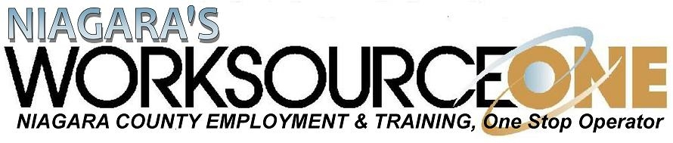 CUSTOMIZED TRAINING
APPLICATION FOR TRAINING FUNDS

PART I: APPLICANT BUSINESS INFORMATION

Applicant Business
Federal Employer ID Number (FEIN) :

Company Name:

Address:

Contact Person
Name:
Title:
Phone: ( ) Fax: ( )
E-Mail:

Company Size Number of Employees: ________

Number, if any, on Layoff: ________ Date of last Layoff:______________

Company Details
Manufacturing Technology Retail
Construction Finance/Insurance Health
Communications _________________________________

Please provide a brief description of company product(s)/services:

Training Timetable *Application must be submitted a minimum of two weeks prior to start of training*
Outline the proposed schedule for training implementation. Include training start and end dates.

PART II: PROJECT INFORMATION – Attach Additional Sheets As Needed
Training Needs
Please select from the list below the need for which you are requesting funds for training. You may request funds for more than one need. Project Information must be submitted for each request.

Changes in equipment and/or software
Changes in product lines
Changes in work processes
Increasing workplace literacy
Other – please describe:

Proposed Outcomes of Project
Number of employees to be trained: _________
Number of NEW jobs created: _________ Number of jobs RETAINED: __________

Please explain how the proposed training will result in increased workforce, lower
turnover / higher retention rates, and/or higher employee wages.

In addition to the above information, describe how this training will have a measurable
positive effect on your business. Include quantitative data if available (e.g., percent of increase
to wages, percent of new business generated).

PART III: PROPOSED BUDGET INFORMATION

- Training Activities, Time Frames, and Cost: If the training project includes more than one course/activity, please list each course/activity separately.

Title of Training Activity/Course | Provider/Instructor  and FEIN* | Total hours of  Training | Number of Employees to receive this  Training | Total Cost

Subtotal Training Activities:

Type of training proposed can include, but is not limited to, vendor training, and use of training consultants. * If Trainer is not listed on the NYS Eligible Training Providers list
(https://applications.labor.ny.gov/ETPL/Search.faces ) a copy of the training curriculum will need to be attached.

B. Employee Eligibility and Wages:

Please list those employees you anticipate will receive training under this grant. Include each potential trainee’s full name and title, date of birth, hourly wage rate, total hours of training they will receive and total cost of each individual’s wages during their training.

Last Name | First Name, Middle Initial | Title | Date of Birth | Current Wage | Total hours of training | Total Wages during Training

Subtotal Wages:

- Non-Personal Services/Supplies Budget
Ex: Workbooks, supplies, etc.

Item (specify) | Cost Per Item | Total Cost

Subtotal Non-Personal Services:

- Funds Received From Other Sources (* Attach documentation itemizing source/amount )

Source | Funding Amount

Subtotal Other Funds:

PART IV: SIGNATURE OF AUTHORIZED REPRESENTATIVES

All applicants must affirm to the following and affix signatures below:
The undersigned affirm that, to the best of my/our knowledge, information, and belief, all statements in this application, including all schedules, appendices, and additional information submitted in connection herewith, are true and accurate. I/we do affirm that I/we will adhere to the non-discrimination and affirmative action policies and requirements of the State of New York.

I/we understand Workforce Innovation and Opportunity grant funds will be used for direct training costs only, and must have a match from our Business of not less than 50% of the project cost for eligible participants.

Applicant(s)

Signature Date

Please Print Name

Please Print Title

Labor Union Information
If applicable, enter labor union information and attach their LETTER OF SUPPORT
Name of Union: Local #:
Contact: Title:

Office Use Only

E. Total of Training Specific Costs (A + C):
F. Total Projected Trainee Wages (B) __________________
G. Total Project Cost (E + F) __________________
H. Funds Received From Other Sources (D):
I. Revised Project Cost (G – H):
J. Employer Match (not less than 50% of I):
K. Grant Total (I – J) *cannot exceed E:

Application received:
Request for additional information:
Application accepted as submitted:
Application denied:

